Ansible Assignment-2

Write a playbook with modules, Install tomcat (zip setup), java 17, deploy the war file, start the tomcat. Initially the WAR file should be available on workstation

- Ansible playbook – On workstation
Target.yaml
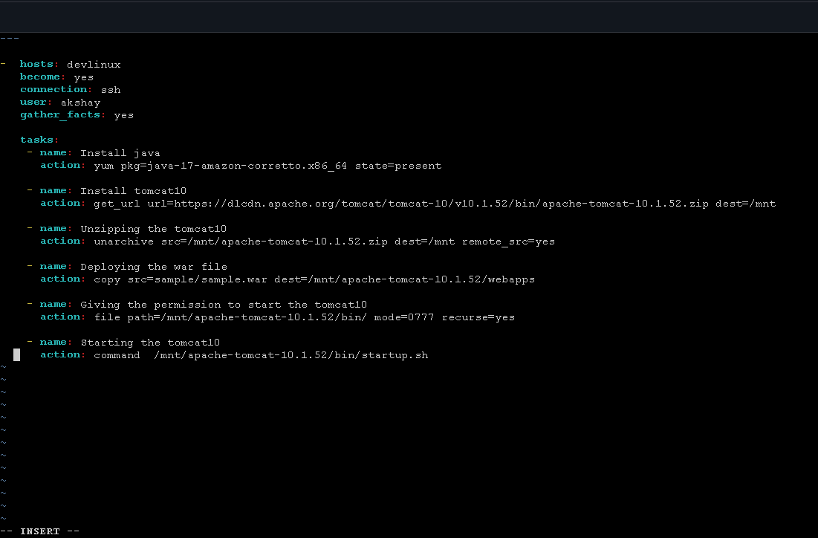

- Output:
